Custom clearance document
Tracking number: 7601379984
Content: Circuit board assembly module

Purpose
This custom PCB is meant for prototyping a game controller (e.g. Xbox gamepad). It supports a microcontroller (ATmega32uA shipped independantly), some connectors for external push buttons and some integrated circuits.
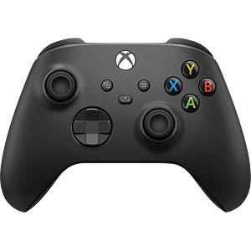
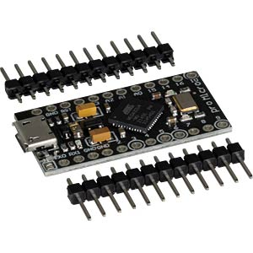

The expected aspect of the product is:
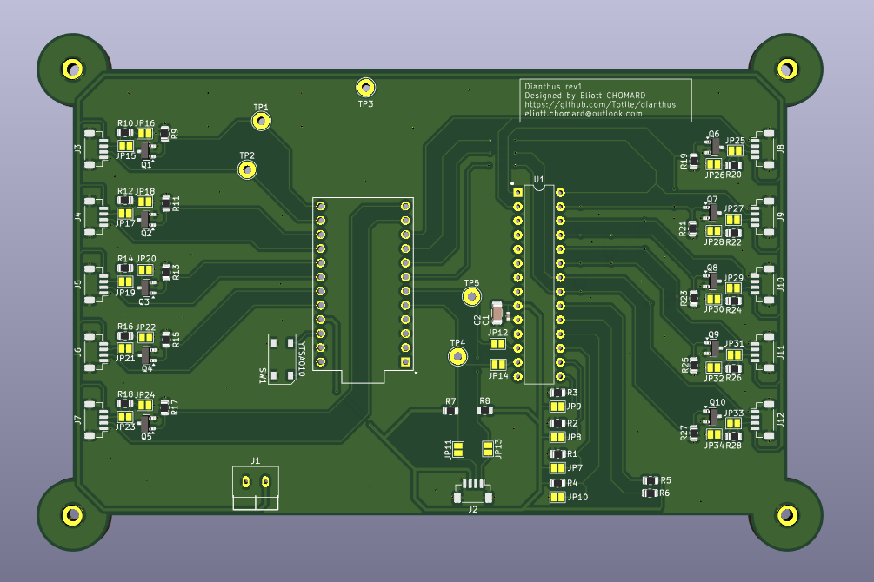
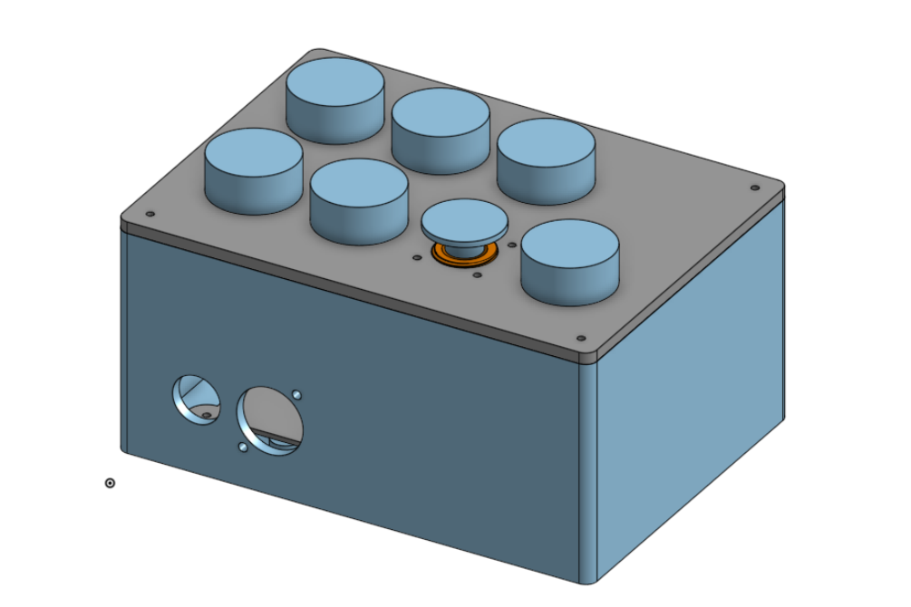

Manufacturing
The manufacturing process used the following settings.
- 2 layers PCB
- 1.6 mm thickness
- base material: FR4
- HASL surface finish
- 1oz/sqft copper thickness
- Assembled in a pick and place machine
It was machined at at JLCPCB PCB manufacturer and designed using Kicad.

